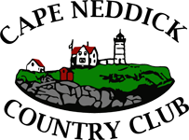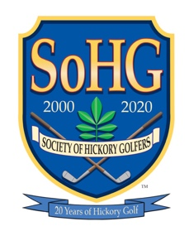

A Donald Ross Course established in 1919

Maine Hickory Tournament
At Cape Neddick Country Club

Saturday, September 25, 2021 – Tee Times starting at 8:30 AM
Cape Neddick Country Club – Cape Neddick, Maine
Join members of the Golf Heritage Society, the Society of Hickory Golfers and the Vermont Hickory Golf Association for the second Maine Hickory Tournament,
that will feature an Open Division, a Senior Division (age 60-70) and a Statesman Division (age 71 and over)
The cost is $60 per player (includes range balls, and awards).
Designed by Donald Ross and established in 1919, the course is well suited to Hickory Stick play.
A brief awards ceremony will follow play. A cash bar will be available for food and drinks.
Prizes will be awarded to:
▪ Low Gross and Low Net Champions in each division ▪
--------------------------------------------------------------------- cut here --------------------------------------------------------------------
REGISTRATION FORM
(Deadline: Tuesday, September 15, 2021)
Name: _______________________________________________________________ Phone: ___________________________________________________
Address: ____________________________________________________________ Email: ____________________________________________________
Hickory Handicap: __________ Steel Handicap: __________
Open Division: _______________________ Senior Division: ______________________ Statesman Division: ________________________
Will play with: ___________________________________________________________________________ _____________________________________
Amt. Remitted: $______________________
Make checks payable to: CNCC Address: P.O. Box 2249, Ogunquit, ME 03907 | Phone: (207) 361-2011 | Email: hez@cnccgolf.com

